Land Use and Land Cover Dynamics in Post Resettlment Areas Using Cellular Automata Model: The Case of Gubalafto Wereda, Ethiopia
E. Lemma

Abstract:
Land is becoming a scarce resource due to immense agricultural and demographic pressure. In this study the land use land cover dynamics and modelling in post- resettlement areas of Gubalfto wereda have been under taken. The study aims to examine and assess if resettlement has brought any change in the land use land cover in the area and to predict the future land use land cover changes using cellular automata model. The result of the work shows a reduction by 2% in settlement and by 4% in agriculture between 1973 and 1986.While the periods between 1986 and 2005 shows an increase in agriculture by 62.5% and settlement by 46%. The trend and rate by which land use land cover has changed also shows that there are reduction in agriculture and settlement between 1973 and 1986 by 2.6km² and 1.5km² per year, respectively. This was because of the 1984/85 resettlement program large number of people leaves their
settlement and agricultural land. Whereas, between 1986 and 2005 agriculture and
22
settlement increased by 3.29km and 2.4km per year than the other classes. This change is because the settlers returned to their origin after resettlement program has passed. Therefore, agriculture and settlements are the main drivers of land use land cover change, which are in turn direct consequences of population growth. It was also observed that the predicted land use classes by 2020 may likely follow the same trend as that of 1986/2005, which means there is an increase in agriculture by 23.5% and settlement by 92% from 2005 but the forest coverage increase by 146%. The rate of change in 2020 will be increased in agriculture and settlement by 5.4km² and by 5km² per year and bush land will decrease by 10km per year. Hence, resettlement has a direct relation with land use land cover change and dynamics.
Keywords: GIS, Remote Sensing, Land use land cover, Modeling, MCE, and Resettlement:

1. Introduction
Mankind's presence on the Earth and his modification of the landscape has had a profound effect upon the natural environment (Zelalem, 2007). These anthropogenic influences on shifting patterns of land use are a primary component of many current environmental concerns; hence land use and land cover change is gaining recognition as key drivers of Environmental change (Zelalem, 2007). Changes in land use and land cover are rapidly increasing, and causing adverse impacts and implications at local, regional and global scales (Lillesand, T., Kiefer, R. and Chipman, J., 2004). Growing human populations exert increasing pressure on the landscape as demands multiply for resources such as food, water, shelter, and fuel(Eastman, 2001). With rapid increases in population and continuing expectations of growth in the standard of living, pressures on natural resource use have become intense. For the resource manager, the task of effective resource allocation has thus become especially difficult (Eastman, 2001). Massive studies were undertaken by FAO and ministry of agriculture in the northern parts of Ethiopia about the problem of ecological degradation, of which the study entitled "The Ethiopian highlands Reclamation study" showed that, of the 5.9 million hectares of land in the highlands, 2.7 million are highly eroded, 1.4 million seriously eroded and 0.2 million are already lost, of which, under cultivation loses about 100 tones of soil per ha every year (RRC, 1984). In response to this facts, the study area Gubalafto Woreda was one of the northern parts of Ethiopia that exposed to the problem of ecological degradation and due to this reason the people were unable to produce enough crop production to feed themselves, hence large number of people leave their destination area and move to the western and south western parts of the country that have a considerable amount of land currently under utilized, which are suitable for farm activities (Desalegn, 1988).
Recent advancement in GIS and remote sensing tools and methods can enable researchers to model and predict land use and land cover changes more efficiently than the traditional approaches. Several modeling approaches have also been developed to model and forecast the dynamics of land use land cover classes. One of the approaches is the Cellular Automata (CA). CA is a dynamical discrete system in space and time that operates on a uniform grid-based space by certain local rules (Alkheder, S. and Shan, J., 2005). The CA is consists of cells and transition rules which are applied to determine the state of a particular cell. Its ability to represent complex systems with spatial-temporal behavior from a small set of simple rules and states made it very interesting for urban studies. In this study an integrated approach of GIS, remote sensing and modeling has been applied to identify and analyze the patterns of land use land cover changes and provide quantitative and spatial information on land use land cover.
The highlands of Wollo in general and Gubalafto Woreda in particular have seriously suffered with ecological degradation and over carrying capacity of people and livestock. The resettlement of people from these drought prone areas to more fertile areas in the south west of the country is considered as a necessary step to improve food production (IDR, 1987). The area has been one of the origins where resettlers were relocated to the south west as a result of land degradation and drought. Thus, this study is intended to study the change in land use land cover before and after the relocation of people. Therefore, attempts were made in this study to map out the status of land use land cover change of settler's origin from 1973 to 2005 and model possible changes that might take place by considering a certain parameters using geographic information system and cellular automata model and to give information how to model land use and land cover changes by increasing the number of factors.

2. Objectives
The general objective is to assess if resettlement has brought any change in the land use land cover in the area and to predict the future land use land cover changes using cellular automata model. The specific objective are:
- To study the land use land cover changes and dynamics in the past 32 year before and after resettlement.
- To determine the trend, nature, rate, location and magnitude of land use land cover changes.
- To identify the major land use land cover drivers.
- To predict and assess the future land use land cover changes.

3. Materials and methods 3.1 Location
The study was conducted in Gubalafto Woreda. The woreda is geographically located
between 39⁰12'9" and 39⁰45'58''East and 11⁰34'54''and 11⁰58'59''North as shown in
2
Figure 1. The Woreda covers an area of 877.85 km , and is bordered by DelantnaWadela Woreda in the west, Gidanenakobo Woreda in the North, Habru Woreda, in the south and in the east. Woldia town is the administrative center of the Woreda. A look at its topographic feature indicate that the town has undulating landscape, surrounded by hills With average elevation of about 1,900 m.a.s.l. measured from the center of the town.
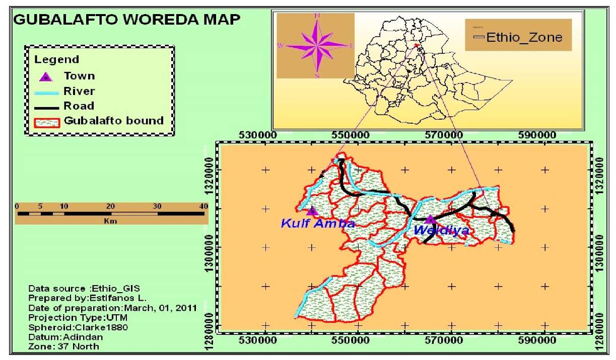
Figure 1. Study area Map
- Climate
A bi-modal nature characterizes rainfall in most parts of Gubalafto Woreda: the short rainy season (Belg), which occurs between February and April and the long rainy season (Meher), which occurs between June and September. In most cases, the highland areas (Dega) are mainly dependent on Belg rain whereas, the Woinadega and Kolla areas are Meher rain dependent for crop production. The principal feature of rainfall in most parts of Gubalafto Woreda is its seasonal character, poor distribution and variability from year to year.
- Geology, Soil and Altitude
The study area dominantly covered with basic and ultra basic rocks (example basalt, gabbro, and pyroxenite etc) and Pyroclastic rocks like, ashes, tuffs and ignimbrites and with a small portion of undifferentiated igneous rock. In the soil map the area is dominated with 92.2% Lithic Leptosols, 3.9% Eutric Cambisols and the remaining 3.5% were Eutric Leptosols (FAO, 1997). The topography of the area is characterized by 20% flat, 30% undulating, 35% mountainous and 15% gorges or Valleys. The altitude of the zone varies from 1379 to 3809 meter above sea level (m.a.s.l). Gubalafto Woreda has four agro-ecological zones, namely, lowland (Kolla) 1379-1500 m a.s.l, Mid-altitude (Woinadega) 1500-2300 m.a.s.l, Highland (Dega) 2300-3200 m.a.s.l, and Wurch >3200 m.,a.s.l.(Gubalafto Woreda agricultural office, 2009).
- Socio-Economic and Physical Characteristics
In Gubalafto Woreda, as in most parts of the country's Woreda, subsistence agriculture is the main occupation of the rural population. It is one of the Woreda in the region, which during the past few decades, has been stricken by drought, unreliable rainfall and consequently to miserable poverty and acute food shortage. Furthermore, soil fertility has dramatically declined due to erosion phenomena caused by deforestation and increase population pressure.
- Land Use Pattern and population distribution
Most of the land is mountainous and characterized by steep slopes, unsuitable for agricultural purpose, thus; agricultural land is limited to 36.42 % of the total area (Woreda environmental protection and land administration office (WEPLAUO), 2009). This has a direct implication that intensified methods of production are the sole means of increasing crop production in the Woreda. The nature of the land coupled with that of population pressure has resulted in individual households farming very small areas. At the Woreda level, the average land holding size for a farmer has been estimated to be 0.78 hectare ranging from 0.4 hectare in the highland areas to 1.93 hectare in the Kolla (lowland) areas of the Woreda (WEPLAUO, 2009).The total populations of the Woreda in 2007 was 195,362 of which, 96,814 were males and 98,548 were females. Of which the urban population of the Woreda was 1732 male and 1803 females and the rural population of the Woreda was 95,082 male and 96,745 females (CSA, 2007).
- Materials
Software: ArcGIS, ERDAS Imagines 9.2, IDRISI Andes and ENVI 4.3, Global positioning system (GPS), Digital Camera, Data types: Satellite Images (1973 MSS, 1986 Landsat, 2005 Landsat), Ethio-GIS data (vector data of Ethiopia), Topographic map, Aerial photographs, Meteorological data, population data and agricultural production data (1977_2005).
- Methods
The satellite images and other maps were projected to a common coordinate system. Using ERDAS IMAGINE software satellite images were, rectified, and enhanced by contrast stretching for better visual interpretation. Then, unsupervised and supervised image classifications were carried out because the classification of satellite images were done based on their spectral reflectance than object based classification. The sample points collected during fieldwork were used for validating classification results. ENVI and IDRSI soft wares are used for Change detection analysis and for factor weighting, scoring using MCE and modeling using CA-markov chain analysis, respectively. ArcGIS software was used for analysis and integration of thematic maps. In order to build the transition rules for the dynamics of land use land cover, the change in the study area was analysed. The overall conceptualisation of land use land cover change and the CA model is as shown in Figure 2.The land use land cover change in the area was initially quantified for the years 1973, 1986 and 2005, so as to analyse the change and the rate of growth. With the quantification of the land use land cover change from 1973 to 2005, modelling studies were undertaken by considering the key driving factors responsible for the change. This model was used to predict the change for subsequent years, thereby setting the land use land cover for the CA transition rules for allocating different land cover classes into different land use land cover categories using supervised classification system in the subsequent year.

4. Spatial data analysis and parameterization 4.1 Land Use Land Cover Dynamics
Satellite image classification has been performed using ERDAS 9.1 software. This is useful for generating a basic set of classes, and then supervised classification has been undertaken for further definition of the classes. In the Supervised training pixels that represent patterns or land cover features have been selected based on the Knowledge of the data, and of the classes desired. In this process, the ground truth data which had been collected in the field have been used in selecting training samples. The result of training is a set of signatures that defines a training sample or cluster. Each signature corresponds to a class, and is used with a decision rule to assign the pixels in the image file to a class. After the signatures are defined, the pixels of the image are sorted into classes based on the signatures by use of a classification decision rule. After classification the result has been evaluated using accuracy assessment cell array. In this paper, overall, producer's and user's accuracy were considered for analysis. The Kappa coefficient, which is one of the most popular measures in addressing the difference between the actual agreement and change agreement, was also calculated. The Kappa statistics is a discrete multivariate technique used in accuracy assessment. The report derived from the accuracy assessment cell array shows that the classification has resulted in more than 89% total accuracy which is the percentage of accuracy, based upon the results of the error matrix. The generated report has also resulted in Kappa coefficient of more than 0.84 for each classified image. Kappa coefficient expresses the proportionate reduction in error generated by the classification process compared with the error of completely random classification. The overall classification accuracy is expressed as the ratio of the sum of correct classifications (diagonals) and the total randomly generated reference pixels (points) used for the assessment.
Land use conversion matrix has been used to study the land use source and destination of change using ENVI 4.3 software. Conversion matrixes for the years 1973 to 1986 and 1986 to 2005 have been produced to investigate the sources and destinations of the land use land cover changes during these time intervals. The annual rate of change between those years also calculated to know how many kilometer square of land each year reduced or added to the given land use land cover classes. Which means Annual rate of change is calculated by dividing the change of the given land use land cover type by the number of years between the two years.

4.2 Land use land cover change modeling
The model applied in this study, CA_Markov, allows us to predict and project the study area land use change. The Markov chain analysis predicts the future land use pattern only on the basis of the known land use patterns of the past. It is also supplemented by the CA approach and a number of change drivers to better understand the change. CA provides a powerful tool for modeling the dynamic nature of land use and is a commonly used method to take spatial interaction into consideration.There are many different CA models in various software platforms and are different options to implement: using an existing model or developing a new model. The later requires extensive and advanced programming knowledge. This study is based on the existing modeling technique "CA_Markov".

Geospatial Inputs
Classifie | Classified | Classifie
d image | image | d image
of 1973 | of 1986 | of 2005

Parameters of land use land cover change model
Distance from the road
Altitude

Rainfall

Land use categories of each image
Settlement
Agriculture
Bare land
Bush land
Water body
Forest
Slope
Layer preparation for each
Population
Distance form Water
Distance form protected areas (forest)

Standardization and Weighting of factors and constraints using
fuzzy method.

Suitability Map (transition rule for CA-Markov model)
Model validation
Land use Map of 1973
Simulated land use map of 2005
+
Land use Map of 1986
Reference land use map of 2005
Calibration and
Land use change prediction for 2020 after validation

The CA_Markov integrates two techniques: Markov Chain Analysis and Cellular Automata Analysis. The Markov Chain Analysis describes the probability of land use change from one period to another by developing a transition probability matrix between ti (1973) and t₂ (1986). The probabilities may be accurate on a per category basis but there is no knowledge of the spatial distribution of occurrences within each land use classes (Eastman, 2001). This is the inherent problem of the Markov Analysis. In order to add the spatial character to the model, therefore, Cellular Automata (CA) is integrated to the approach. In the CA analysis, the land use was treated as a dynamic system in which space, time and the states of the system were treated discretely. The Cellular Automata component of the CA_Markov model allows the transition probabilities of one pixel to be a function of neighboring.
Unlike the constraints, factors define some degree of suitability and provide alternatives in terms of a continuous measure of suitability. These criteria do not absolutely constrain land use land cover change, but enhance the relative suitability of an area for land use land cover change (Eastman, 2001). The criteria are often obtained or selected in collaborations with Gubalafto Woreda agriculturalist, administrators and environmentalist based on the ability of the factors to change land use land cover in the future. In order to develop the criteria for MCE and implement the CA_Markov model, the factors affecting land use land cover changes were first identified (Anuj, K., 2003). Each change drivers were classified in to five types based on their suitability; which means, Very highly suitable, highly suitable, moderately suitable, suitable and poorly suitable for future land use land cover change prediction. The factors considered are listed and described in (Table 1). This land use land cover prediction were made by assuming that slope and altitude were not changed throughout the prediction period, where as rain fall were assumed to be similar to that of the past 32 years annual average rainfall, population growth were taken by using the 1994 population census medium level growth rate and land use land cover were taken as it is. Finally the road factor was taken as it is, because this study considers only the main road, but there may be additional road expansion within the study area.
Table 1. Description of |  | actors and their types
Factors | Type1 | Type2 | Type3 | Type4 | Type5
Slope | <15⁰ | 15_55⁰ | 55_65⁰ | 65-85⁰ | >85⁰
Altitude | <1500m | 1500-2000m | 2000- 2500m | 2500-3000m | >3000m
Rainfall | <500 mm | 500-1000 mm | 1000-1200 mm | 12001400mm | >1400mm
Population Density | <75 | 76-130 | 131-200 | 201-300 | >300
Land use | Bare land and bush | Agriculture | Forest | Water body | Settlement
Road | <1km | 1-2km | 2-2.5km | 2.5-5km | >5km

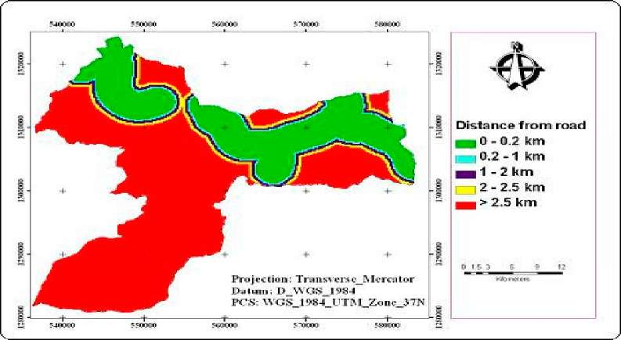
Figure 3. Proximity to main road
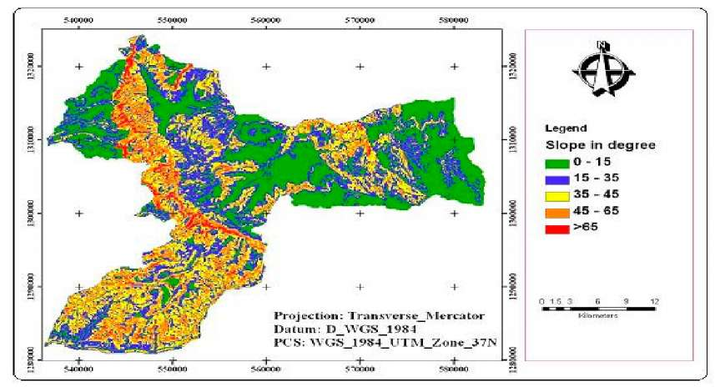
Figure 4. Slope class Map

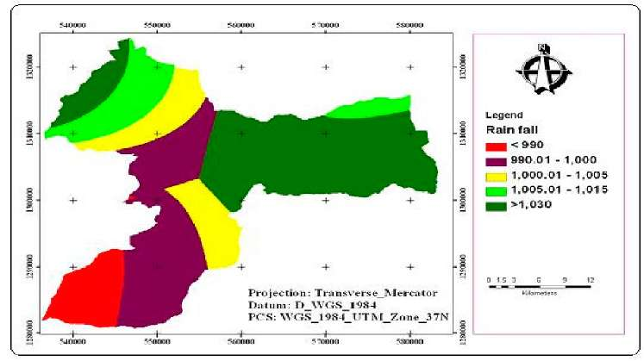
Figure 5. Map of rainfall
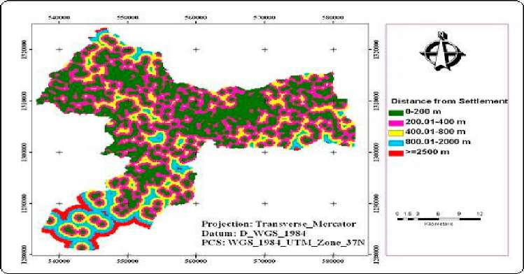
Figure 6. Proximity to settlement areas
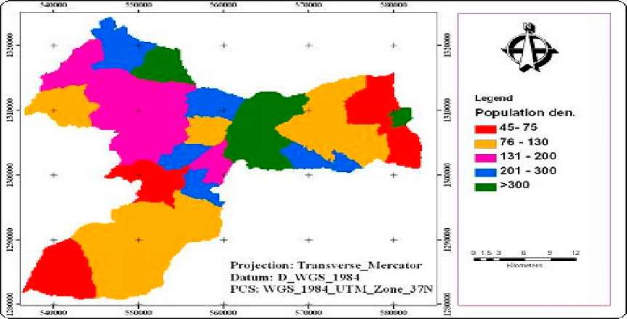
Figure 7. Map of population density

Figure8. Map of Altitude
fMWOO MOOOO F500QQ 5"0000 fSQOOO 3WWQQ J I JL I I L
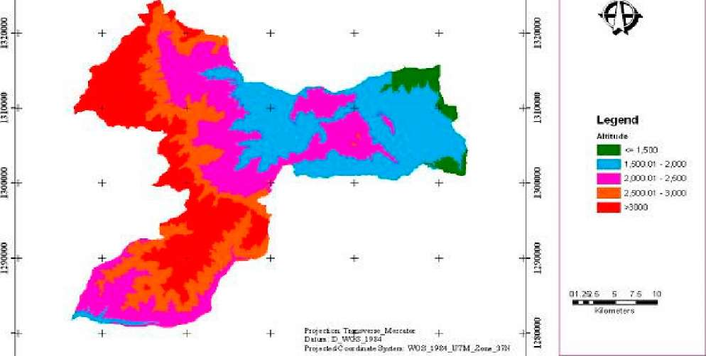
550000 MOOCW 550000 560000 5MG00 rSOOUU 590000
Establish a set of weights for each of the factors studied and the analyst has to fill out the pair wise comparison matrix using the Weight module in Idrisi. The pair wise comparisonwas developed by (Saaty, 1977 cited in Eastman, 2001) in the context of a decision making process known as the Analytical Hierarchy Process (AHP). This module uses a pair-by-pair technique to compare the relative importance of one factor (e.g. road) against another factor (e.g. slope). The rating ranges from "extremely less important" (1/9) to "extremely more important" (9). The rating is subjective and entirely depends on the analyst. The weights derived from the pair wise comparison matrix and assigned to each of the suitability variables. Consistency ratio = 0.04 and hence, Consistency is acceptable (Saaty, 1977).

4. Result and Discussion

4.1 Land use land cover change
The land use land cover percentage and the area coverage of each land category for each study year were derived from the three satellite image. Image classification of (1973, 1986 and 2005) has resulted six land uses land cover classes: Agriculture, settlement, Forest, Bare, Bush and water body. In Figure 9 and Table 2 of 1973 image result, 3.04% of the study area has covered with water body. About 34.25% and 16.31% of the study area were covered by bush and bare land, respectively. Agriculture is mainly practiced throughout the study area and it covered 36.20% in 1973. 6.3 % and 4 % of the study area were also covered with scattered settlement and Forest, respectively. Generally, in 1973 as indicated in Table 2 the area was mostly covered with agriculture and bush lands, whereas, forest land and water body occupies the smallest area. In 1970's especially 1973/1974 and 1984/85 due to the occurrence of drought and famine the coverage of agriculture, bush land, forest, settlement and water bodies decreased (Desalegn, 1988).
Therefore, in 1986 Agricultural land had reduced to 32.30% from 36.2% of the 1973 (Table 2). Bush land and settlement area were reduced to 32 % and 4 % in 1986 from 34 % and 6.3 % of the 1973 respectively. The water body has covered 0.7 % and forest has covered with 1.3 % and in 1986 but bare land had increased from 16 % in 1973 to 30 % in 1986. In 1986 bare land covered the largest portion of the area, it is because most of the other land use land cover classes were reduced and changed to bare land due to problem of drought and famine during 1984/85 periods. Therefore the productive lands become changed to infertile (bare) land and the people become exposed to hunger and hence the government takes the 1984/85 resettlement program in the study area. Figure 10 shows the 1986 land use land cover classes of the study area. The result of landsat 2005 image could clearly be indicated that the water body, the forest resources and the bush land has tremendously been degraded (Table 2 and Figure 11). The forest and bush land found in the study area were reached to 1% and 18.4 %, whereas agriculture, scattered settlement has increased up to 39.4 % and 9.4 % respectively.
Table 2 Land use lands cover of 1976, 1986 and 2005
Land use land | 1973 |  | 1986 |  | 2005
cover | Area | Area (%) | Area | Area | Area | Area (%)
categories | (Km².) |  | (Km².) | (%) | (Km².)
Agriculture | 317.79 | 36 | 283.54 | 32.3 | 346.02 | 39.4
Settlement | 55.17 | 6.3 | 36.33 | 4 | 82.19 | 9.4
Bare land | 143.19 | 16.3 | 259.02 | 29.5 | 257.24 | 29.3
Bush land | 300.63 | 34.3 | 281.15 | 32 | 161.6 | 18.4
Water body | 26.67 | 3 | 6.23 | 0.7 | 22.29 | 2.5
Forest | 34.4 | 4 | 11.58 | 1.3 | 8.51 | 1
Total | 877.85 | 100.00 | 877.85 | 100.00 | 877.85 | 100.00

s»
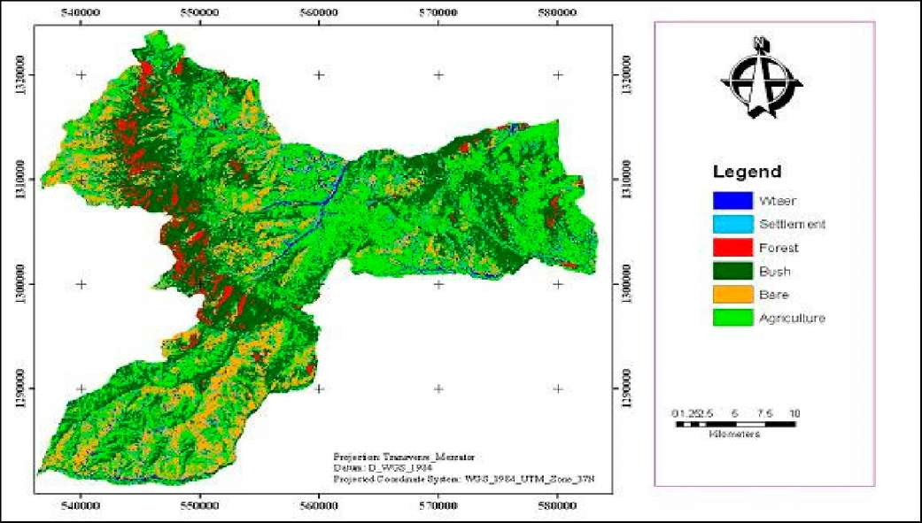
Figure 9 Land use map of 1973
Legend
| VVSEer
Ml t-9'Hern c-nl Forest Bu-sh Bare
Agric-j^ure
Figure 10 Land use map of 1986
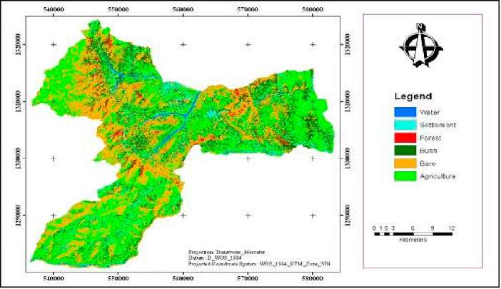
Figure 11 Land use map of 2005
The water body has increased to 2.5 %, this is because the drought period during 2005 becomes reduced and the water body replenish well. On the other hand the area of the bare land is almost equal to that of the 1986, which means 29.30%.

4.2 Trend and Rate of land use land cover change
Table 3 shows the trend and rate of the land use land cover change of the study area (settlers' origin) from 1973 to 2005 before and after relocating the settlers.In Table 3, there was a negative change in agriculture by 4 % which means a reduction in farm land between 1973 and 1986 by 4 %. This is because of the agricultural land of settlers became changed to bare and bush except the most fertile and the closer agricultural land to the settlement area (Desalegn, 1988). Subsequently, settlement also decreased by 2.15% because of the resettlement program in 1983/84 the settler's leave from their localities (settlements). Therefore, the settlement areas become changed to other land use classes like agriculture and bare land.
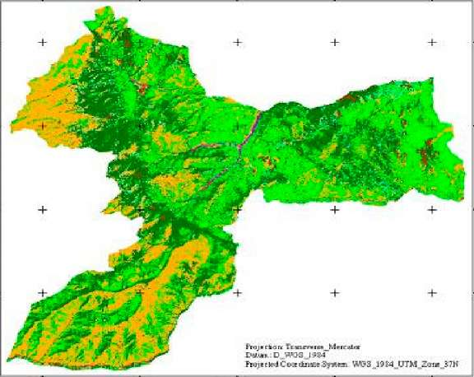
54J3DOQ 550000 560000 5TMXI 5SOOOO
t
II
-J
-I
^{c}-joooii "norm cumao 51001x1 ^sriooo

In Table 4 shows the land use land cover dynamics between 1973 and 1986.In Table 8 the highlighted diagonal indicates the stable land classes' which were not changed to other classes between 1973 and 1986 this is true for 1986 and 2005 land use land cover dynamics. But the off diagonal areas of each class indicate the changes of one class to the other by losing or gaining from the initial state. The column total of the table indicates the total area of that particular land use land cover class of the initial state (1973); whereas the row total indicates the area of that particular land use land cover class of the final state (1986).

Table 3: Ternd of the land use and land cover change
Land categories | 1986-1973 |  | 2005-1986 |  | Annual rate of change
Land categories | Km² | % | Km² | % | 1986-1973 | 2005-1986
Agriculture | -34.25 | -4 | 62.48 | 7 | -2.63 | 3.29
Settlement | -18.84 | -2 | 45.86 | 5.2 | -1.45 | 2.41
Bare land | 115.83 | 13.2 | -1.78 | -0.2 | 8.91 | -0.09
Bush | -19.48 | -2.2 | -119.55 | -13.6 | -1.50 | -6.29
Water | -20.44 | -2.3 | 16.06 | 1.8 | -1.57 | 0.85
Forest | -22.82 | -2.6 | -3.07 | -0.4 | -1.76 | -0.16
While bare land tremendously increased by 13.2 %, because all the other factors; bush, agriculture, forest and water bodies reduced and changed to bare land due to the occurrence of the repeated drought and therefore coverage of the bare land becomes increase. Due to the expansion of bare land the production of the area becomes reduced and it leads to the starvation of the people and this finally looks a new option to sustain the problem, which is known as resettlement.
Furthermore, water body, bush land and forest were decreased by 2.3%, 2.2% and 2.6% respectively, though there are great differences in the total land use land cover between these periods in all types of land categories. On the other hand in 1986 and 2005 there was an increment in agriculture, settlement, and water bodies by 7 %, 5.2 %, and 1.8 % respectively. The reason for this increment in Agriculture and settlement were that the
people of the area coming back from the resettlement area and occupy new settlements and agricultural area. In addition in 1996 due to the higher demand for agriculture and settlement from the public especially from the youngster the government under take land redistribution. A large number of youngsters and women have got agricultural land and settlement areas with a distribution rule of highly fertile, moderately fertile and less fertile lands (Gubalafto Woreda agricultural office, 2009). In this case the less fertile lands are lands that were not previously occupied and used for agriculture. And hence it was a new land that was added to agriculture and settlement comes from free lands like bare and bush lands. On the other hand bush land and bare land decreased by 13.6 % and 0.2 % respectively, this is because of the above mentioned reason.
The annual rate of change is area difference between the two years divided by the number of years between them and in most land use land cover categories the area is reduced by more than one kilometer square per year between the year 1973 and 1986 except bare land which increased by 8.91km² per year. Between the year 1986 and 2005 the annual rate of change in agriculture and settlement increased by more than 2km per year but the remaining land use types decreased by less than one kilometer square except bush land which is decreased by 6.29 km per year.Generally the trend and rate of land use land cover between the 1973 to 1986 shows that a reduction in agriculture, bush, settlement, forest and water bodies, whereas bare lands were highly increased from 1973 to 1986 due to this reason the settlers were relocated from their area to the south west Ethiopia. Land use land cover trend and rate between 1986 to 2005; agriculture, settlement and water bodies had increased, whereas bush land, forest land and bare land had decreased as compared to the previous years because the drought and famine period during these time were reduced and the settlers return back to their areas and expand the utilization of bush, forest and bare land for settlement and agriculture and therefore the coverage of agriculture and settlement increases, whereas the coverage of bush, bare and forest land decreased.

4.3 Land use land cover dynamics
An important aspect of change detection is to determine what is actually changing to what which means, which land use class is changing to the other. This information will tell both the desirable and undesirable changes and classes that are "relatively" stable overtime. This information will also serve as a vital tool in management decisions. Table 4 and 5 expresses about the nature and location of change in the study area land use land cover categories form 1973 to 2005.

Table 4 Land use land cover dynamics from 1973 to 1986
To 1986 "Final state" | Form 1973 "Initial state''
To 1986 "Final state" | Land use category | Agric. | Bare | Fore st | Bus h | Wat er | Settle ment | Row Total | Class Total
To 1986 "Final state" | Agriculture | 166.65 | 23.81 | 2.55 | 63.76 | 10.77 | 15.19 | 282.73 | 283.87
To 1986 "Final state" | Bare | 75.74 | 97.61 | 4.61 | 42.45 | 10.23 | 28.79 | 259.44 | 260.18
To 1986 "Final state" | Forest | 2.97 | 2.97 | 1.81 | 5.32 | 0.19 | 0.44 | 11.36 | 11.38
To 1986 "Final state" | Bush | 60.02 | 14.82 | 21.88 | 174.28 | 1.79 | 8.15 | 280.94 | 281.91
To 1986 "Final state" | Water | 2.58 | 0.28 | 0.02 | 0.4 | 2.72 | 0.19 | 6.19 | 6.19
To 1986 "Final state" | Settlement | 9.83 | 6.05 | 2.66 | 14.42 | 0.97 | 2.41 | 36.35 | 36.42
To 1986 "Final state" | Class Total | 320 | 143.98 | 33.81 | 302.54 | 26.87 | 55.46 | 0 | 0
To 1986 "Final state" | Class Changes | 153.35 | 46.37 | 31.99 | 128.27 | 24.14 | 53.05 | 0 | 0
To 1986 "Final state" | Image Difference | -36.13 | 116.2 | -22.43 | -20.63 | -20.67 | -19.04 | 0 | 0

Thus, by giving a greater emphasis for agriculture and settlement between 1973 and
2 2 1986, agriculture has a loss of 153.35 km form 1973 and it is changed to 75.74 km
bare, 60.02 km² bush and 9.83 km² settlement in 1986.On the other hand agriculture
gain 117.22 km² in 1986 from the land use land cover classes of 1973; 63.76 km² form 2 2 2 bush, 23.81 km form bare land, 15.19 km formsettlement and 10.77 km water. 166.65
km of the area of agriculture remains stable, which means it doesn't change to other
land use land cover types. Settlement losses 53.03 km form 1973 and changed to 2 2 2 2 28.79 km bare, 15.19 km agriculture and 8.15 km bush. It also gain 31.04 km in
22
1986 from 1973 land use land cover classes: 14.42 km Bush, 9.83 km agriculture and 6.05 km² bare land and the rest from forest and water body.
The reason for losing, gaining or changing of agriculture and settlement to other land use land covers were the occurrences of repeated drought (low rain fall amount) and population growth made bare land and bush lands to be highly utilized for agricultural purposes but also left the highly degraded agricultural lands as fallow because of less productivity especially the highlands of the study area. In addition these two years indicate the happenings of the land use land cover change or dynamics before and during resettlement and hence before resettlement there were a wide coverage of agriculture and settlement in 1973 but during resettlement the coverage of agriculture and settlement were reduced and changed to other land use land cover classes. Therefore the resettlement program reduces the pressure of population and due to this reason large number of settlement and agriculture become changed largely to bush and bare land.
Table 5 shows the land use land cover dynamics from 1986 to 2005. Based on this, the
land use land cover dynamics of each class were discussed. Agriculture losses 147.85
km² from 1986 and changed to : 51.56 km² bare land, 51.22 km² bush land, 35.92 km² 22 settlement,7.24 km forest and 0.22 km water in 2005. On the other hand it gains
209.25 km² from 141.37 km² bare, 52.19 km² bush, 11.12 km² settlement, 2.5 km² 22 forest and 1.46 km water of 1986. Whereas settlement losses 45.88 km from 1986
2 2 9 9
changed to 11.12 km agriculture, 11.99 km , bare land, 9.96 km bush, 0.77 km water
bodies and 0.12 km forests in 2005. It also gain 79.82 km from 35.92 km agriculture,
30.42 km bare land, 11.56 km bush, 1.07 km water bodies and0.85 km forest of 22 1986.only 137.38 km agriculture and 2.37 km settlement were stable.
As discussed in the above paragraph the exchange of land use land cover classes during the 1986 to 2005 were occurred after the 1984/85 resettlement program. That means large number of population returned back and occupies large area of agricultural land and settlement. Therefore the coverage of agriculture and settlement were increased, on the other side bare and bush land were reduced. This shows that agriculture and settlement are the main drivers of the land use land cover change. Population and the rain fall fluctuation were also land use land cover change drivers.
Table 5 Land use land cover dynamics from 1986 to 2005
To 2005 "Final state" | Form 1986 "Initial state''
To 2005 "Final state" | Land use land cover class | Agric. | Bare | Forest | Bush | Water | Settlement | Row Total | Class Total
To 2005 "Final state" | Agriculture | 137.38 | 141.37 | 2.5 | 52.19 | 1.46 | 11.12 | 346.02 | 346.63
To 2005 "Final state" | Bare | 51.56 | 40.4 | 2.36 | 150.85 | 0.08 | 11.99 | 257.24 | 257.93
To 2005 "Final state" | Forest | 0.22 | 0.06 | 0.74 | 7.37 | 0 | 0.12 | 8.52 | 8.52
To 2005 "Final state" | Bush | 51.22 | 43.43 | 4.77 | 51.99 | 0.23 | 9.96 | 161.6 | 161.78
To 2005 "Final state" | Water | 7.24 | 3.34 | 0.36 | 7.19 | 3.39 | 0.77 | 22.3 | 22.33
To 2005 "Final state" | Settlement | 35.92 | 30.42 | 0.85 | 11.56 | 1.07 | 2.37 | 82.19 | 82.32
To 2005 "Final state" | Class Total | 284.22 | 259.69 | 11.61 | 281.75 | 6.23 | 36.44 | 0 | 0
To 2005 "Final state" | Class Changes | 146.85 | 219.28 | 10.87 | 229.76 | 2.84 | 34.07 | 0 | 0
To 2005 "Final state" | Image d/ference | 62.41 | -1.76 | -3.09 | -119.97 | 16.1 | 45.88 | 0 | 0

4.4 Land use land cover prediction for the year 2020
After calibrating the model and assessing its validity, it was interesting to examine the pattern and tendency of the change for the future. Therefore, prediction for the year 2020 was carried out in the same way by considering land use land cover maps of the year 1986 and 2005, the transition area matrix, a contiguity filter and the transition suitability collection. Based on these the predicted land use land cover map of 2020 was produced (Figure 12). Visual analysis of the simulated result indicates that settlement and agriculture areas will occur at very high rate of growth (Table 6).
Land use categories | Area in Km² (2020) | Area in% | Area of (2005) in Km² | Difference in |  | Annual rate of change of 2020-2005 in Km²
 |  |  |  | Km² | % | Annual rate of change of 2020-2005 in Km²
Agriculture | 427.23 | 49 | 346.02 | 81.21 | 23.5 | 5.4
Settlement | 157.71 | 18 | 82.19 | 75.52 | 92 | 5
Bare and bush land | 267.29 | 30.5 | 418.84 | -151.5 | -36 | -10.1
Forest land | 20.95 | 2 | 8.51 | 12.44 | 146 | 0.83
Water bodies | 4.24 | 0.5 | 22.29 | -18 | -79 | -1.2
Table 6 Projected Land use lane
cover change by 2020 and actual area of 2005

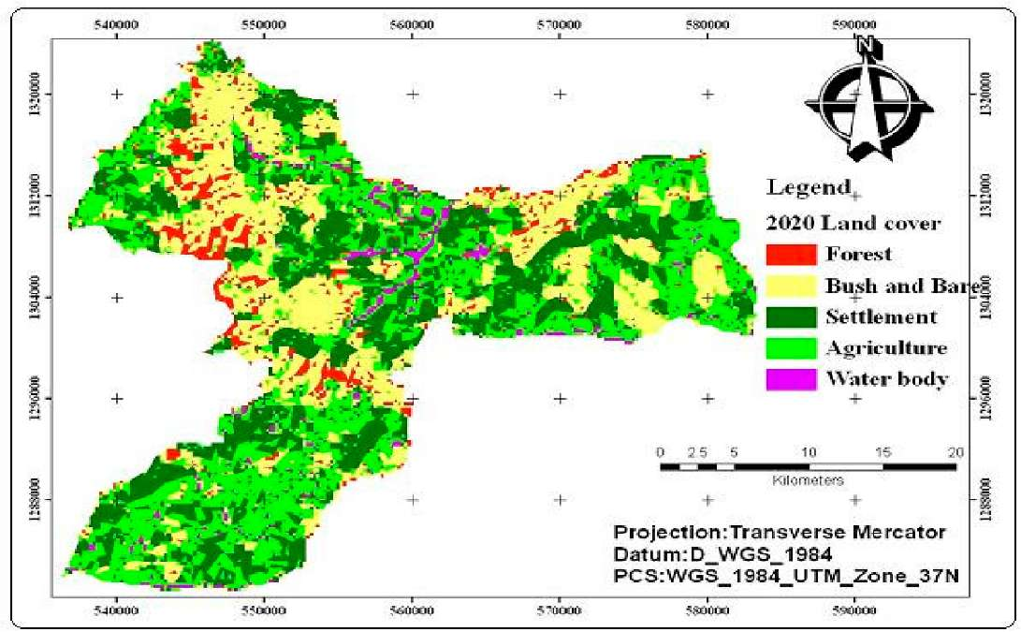
Figure 12. The predicted land use map of 2020
Table 6 above shows the area of land use land cover projection by 2020 and the actual area of 2005. Comparing to the percentage representations Table 6, some similarities exist in the observed land use land cover change between projected 2005 and 2020. This may tend to suggest no change in the class types between 2005 and 2020, but a careful look at the area coverage between these two years shows a change. Thus in Table 6, the projected 2020 agriculture maintains the highest position in the class, 49 %, bare and bush land takes up the next position in common, 30.5%, followed by settlement, 18 %, forest land, 2.4% and finally water body takes the least position, 0.53%. Forest land was increased by 146 % from 2005 because during model
development forest and settlement considers as constraint, that means whatever the case may be the two class may not be changed to other classes rather they increases. Also agriculture and settlement increases by 23.5 % and 92 % respectively from the initial 2005. But water bodies decreased by 79 % and bare and bush in common decreased by 36 %.
The rate and trend of agriculture and settlement also shows the highest increment from 2005 to 2020 as shown in Table 2 &3 both agriculture and settlement increases by 5 Km² annually, which is the maximum increment than the other. Bare and bush land in common decreased by 10.1 km per year from 2005 to 2020.This also shows that agriculture and settlement had been the main drivers of the future land use land cover change. The results of the simulation indicate that there will be a significant land use changes in the future. As discussed in the actual land use land cover change analysis, settlement and agriculture were the main driving forces for land use land cover change. On the other hand the expansion of infrastructure around the main land use land cover type also aggravates land use land cover changes. Accessibility to main road, rain fall distribution, slopes, population density and altitude were also been other driving forces for land use land cover change in the future.
To reduce the pressure of changing most land use land cover of the area to agriculture and settlement may increase the ecological disturbance of the area as well as increase land degradation due to plowing of steep slope areas and protected areas due to the growth of the population. Therefore resettlement may take us an option for protecting the ecology (the land use land cover) of an area in the future.

5. Conclusions and Recommendations 5.1 Conclusions
The main causes of LULC change and dynamics are linked to different policy issues, physical factor (slope, altitude and other), proximity factor (nearest road, settlement and other infrastructure) and other socioeconomic factors that have direct impacts on population and local level resource use patterns. The land use land cover before resettlement shows that there is higher coverage in agriculture, settlement and bush than bare land, forest and water bodies. But during the resettlement (1986) the result shows a reduction in agriculture, settlement and bush land, whereas bare land increased. In 2005 after resettlement agriculture and settlement increased in its coverage than the coverage before and during resettlement. But there are reductions in bush and forest coverage, with no change in the coverage of bare land.
The trend and rate land use land cover change also shows that there are reductions in
22
agriculture and settlement between 1973 and 1986 by 2.63 km and 1.45 km per year
respectively. Whereas, between 1986 and 2005 agriculture and settlement increased by
22
3.28 km and 2.41 km per year respectively. Therefore, agriculture and settlements are the main drivers of land use land cover change, which are on the other hand, the direct consequences of population growth. The land use land cover dynamics also indicates that vegetation cover were highly converted or changed to non vegetation, than vegetation to vegetation. That means bush and forest classes were changed to agriculture, settlement and bare land. On the other hand the conversion or transitions from non-vegetation to vegetation were very less.
The future land use land cover change prediction indicates that there will be an increase
22
in agriculture and settlement by 5.4 km and 5 km per year respectively. The prediction result shows a direct link between the year 2005 land use land cover change. Which means the result of the 2005 shows an increase in agriculture and settlement than the other classes, the same is true for the result of 2020 predicted land use land cover change. Therefore, reducing the pressure of population on land use land cover may the better way to reduce the change and dynamics of land use land cover classes. Hence resettlement can act as an option to reduce the land use land cover change.

5.2 Recommendations
Increasing population density accelerates land use land cover change and dynamics, so as to reduce the pressure of population on land use land cover change and dynamics resettlement will have a significant impact.The result of land use land cover dynamics indicates that vegetation to non-vegetation increases, this implies that there will be a continuous reduction in vegetation covers in the future, unless better remedies are under taken such as planting trees, protecting the existed vegetation areas, encouraging individual tree growers etc.
Land use land cover prediction of the study indicates there will be an increase in the area of agriculture and settlement; this is because of the continuous growth of population, infrastructure development and physical factors. Therefore, concerned bodies ( governmental office and NGOs like office of health, office of population and family life education, agricultural offices and land administration offices etc.. ) will prepare proper land use plan to reduce the expansion of settlement and agriculture, to protect forest and water bodies.Predictions of future land use land cover change will be very useful to land use planners for planning and implementing socio-economic development programs. Increasing the awareness among peoples will be an important issue to utilize lands intensively than using extensively.Finally further research should be made to achieve better land use land cover prediction in the same method by adding the necessary information, applicable data and by filling the above mentioned limitations.

Acknowledgements
I would like to express my deep gratitude to my research advisor Dr.K.V.Surya Bhagavan for his skilful guidance and support throughout this research work. I am very grateful to my second advisor Dr.Mekuria Argaw for his continuous support and constructive comments on the final thesis and again I thank for the financial support I received from his NARF project. Without their support, critical and valuable comments and suggestions, this paper would not have had its present shape. Thus, they deserve special thanks.The efforts of my lecturers in the department of Earth science: Dr. Dagnachew Leggese, Dr.Mohammod Umer, Dr.Tarun Kumar Raghuvanshi and other staff members for their encouragement and cooperation during my stay is highly acknowledged. I remain indebted to the entire staff of North Shoa Zone Environmental and land administration office, North Wollo zone Agriculture and Land administration office, Gubalafto Woreda Agricultural office and Environmental and land administration office for their untried help during my field work. My thanks also go to Amhara region environmental protection and land administration office for sponsoring and helping me to get this opportunity, Ethiopian Meteorological Agency, Ethiopian Central statistics agency and Addis Ababa University, for providing me all the necessary information and data that are helpful for this paper. My special thanks also go to all my friends to mention some in persons: Efrem Haile, Tiruneh F/h, Yirga Ayalew, Abebaw Lemma and others who encourage and support me financially, technically and morally throughout the duration of the course; I say God will reward you greatly.
The support and encouragement that I have obtained from my wife Mestawot Moges was a driving force throughout my study time. She has taken all responsibilities in making things at home more convenient and pleasant, thank you.

References
Alkhederm, S. and Shan, J. (2005). Cellular Automata Urban Growth Simulation and Evaluation - A Case Study of Indianapolis. Geometrics Engineering, School of Civil Engineering, Purdue University. URL: //www. geocomputation.org/2005/Alkheder. Anuj, K. S. (2003). ModelingLand use land cover changes Using cellular automata in a Geospatial Environment.International Institute for Geo_information science and Earth observation Enshede,TheNetherlands.
ttp://iirsnrsc.gov.in/student thesis/msc geoinformatics/2002 2003/finalthesis anuj.pdf (Jan,
Central Statistical Agency of Ethiopia (2007). Population and housing census of Ethiopia Summery Section_B; July 2007.
Congalton R. G. (1991). A review of assessing the accuracy of classifications of remotely sensed data. Remote Sensing of Environment 37(1): 35 46. Desalegn Rahmeto (1988). Settlement and resettlement in Mettekel, Western Ethiopia. Rome 1988.Famine and survival strategies: case study from Northern Ethiopia Food and Famine monograph. Institute of Development Research, AAU 1987. Eastman (2001). Idrisi 32, Guide to GIS and Image Processing, Clark Labs, Clark University, Worcester, MA, USA.
FAO (1997).The Digital soil and Terrain Database of East Africa (SEA) Notes on the Arc Info Files Version 1.0, Food and Agriculture Organization of the United Nations, April 1997.
IDR (Institute of Development Research) (1987). Proceedings of work shop on famine experience and resettlement in Ethiopia, Institute of Development Research Addis Ababa.
Lillesand, T., Kiefer, R. and Chipman, J. (2004). Remote Sensing and Image Interpretation, 4thed. New York: John Wiley & Sons.
Macleod and Congalton. (1998). A Quantitative Comparison of Change Detection Algorithms for Monitoring Eelgrass from Remotely Sensed Data. Photogram metric Engineering & Remote Sensing. Vol. 64. No. 3. p. 207 -216. Mekuria Argaw Denboba (2005). Forest conversion - soil degradation - farmers' perception nexus: Implications for sustainable land use in the southwest of Ethiopia. Ecology and Development Series No. 26, 2005, Cuvillier Verlag Gottingen. Pontius Jr, R.G., (2000).Quantification error versus location error in comparison of categorical maps. Photogram-metric Engineering and Remote Sensing. https://www.clarku.edu/~rpontius/pontius_2000_pers.pdf(April,2009) RRC (Relief and Rehabilitation commission) (1984). Review of the current drought situation in Ethiopia. Resettlement a lasting solution for people in drought affected areas. Unpublished report 1984.
Saaty, T. L. (1977). A scaling method for priorities in hierarchical structures. Journal of Mathematical Psychology 15(3): 234-281.
Yikalo Hayelom Araya (2009). Urban land use Change Analysis and Modelling: A case study of Setubal and Sesimbra, Portugal, Institute for Geoinformatics UniversityofMunste. http://www.igeo.pt/gdr/pdf/Tese Yikalo Araya.pdf(April,2010) Zelalem Amdie (2007). Land Use/ Land Cover Dynamics and Vegetation Vulnerability Analysis: a Case Study of Arsi Negele Wereda. Unpublished paper, Addis Ababa University, Addis Ababa.

